Sheffield SCUBA. COVID-19 Update as at 26/10/2020 Ponds Forge
Returning to swimming pool guidance as at 18/06/2020

The following guidance is based on the BSAC guidance available at the following locations
https://www.bsac.com/advice-and-support/covid-19-advice-and-support/safe-return-to-divingguidance
https://www.bsac.com/document/snorkel-guidance
and the guidance published by Swim England https://www.swimming.org/swimengland/returning-pools-guidance-published/

This information is intended to draw out the key points for members of Sheffield Scuba only. It does not replace the above guidance, and the BSAC guidance is always deemed to be the most current. This guidance was produced by Tessa Fisher, Sheffield Scuba Chair on Monday 26th October 2020 & includes sections of information issued by Matt Newbound, Sheffield Scuba on Sunday 14th June 2020.
Be aware that guidance is evolving, not all factors are currently known and that circumstances will change and we await information from the pool operator regarding a potential reopening & guidance provided regarding use in the future. The guidelines are made in relation to safe conduct of use of pool facilities but do not imply that it is currently acceptable for this use if it is not consistent with the prevailing government rules.
All users /attendees at a swimming pool should ensure that they fully read all the relevant guidelines (BSAC, Swim England and Sheffield Scuba) in order to ensure that they do not place themselves or others at increased risk of either infection or diving injury.

1. Ensure you are familiar with the UK Government guidance on COVID-19: https://www.gov.uk/government/collections/coronavirus-covid-19-list-of-guidance Anyone displaying any symptoms should NOT engage in any activity outside the home. Ensure you are not showing any symptoms of Coronavirus (temperature, cough, difficulty breathing, or loss of smell and/or taste). Follow Government advice:
• Follow any specific guidance from your devolved administration
• Stay at home if you’re showing symptoms of Covid-19 or self-isolating
• Respect 2m social distancing
• Commit to hand hygiene.
Should anyone attending become unwell or suspect they have the symptoms of Covid-19 they should leave the pool immediately & return to their home / medical facility if appropriate directly. If Covid-19 is confirmed all persons present at the pool & the pool operator are to be notified without delay.

2. Medical Fitness to Dive:
Divers who have either tested positive or been treated for Covid-19 should consult a UK DMC medical referee to ensure you are safe to resume diving.

3. Travel to site:
Ensure you travel to site on your own, or only with members of your own household.

4. Use of Ponds Forge pool facilities – prior to arrival
a) members to advise the person responsible to liaising with the pool a least 24 hours prior to the date of pool use as this information is to be recorded & provided to Ponds Forge (you will be advised as to whom this person will be each week)
b) Octopus regulators & BC oral inflate valves in particular to have been cleaned & covered in plastic bag to prevent contamination prior to use.
c) Members to be ‘swim ready’ that is wearing swimwear

5. Use of Ponds Forge pool facilities – upon arrival
- Members to meet (socially distanced & face coverings optional) in the car park closest to the exit (just before the arch leading to the Bus station/ Queens Head) BEFORE 7:45pm.
- The person who has collated details of those attending is to confirm attendees & take details to the reception of Ponds Forge& subsequently open the fire escape doors adjacent to the dive pit which are to be used for entry/exit.
- Entry will be made available, via the double doors from the car park to poolside, to access these doors turn left at the end of the building. I understand the doors may be these shown below: 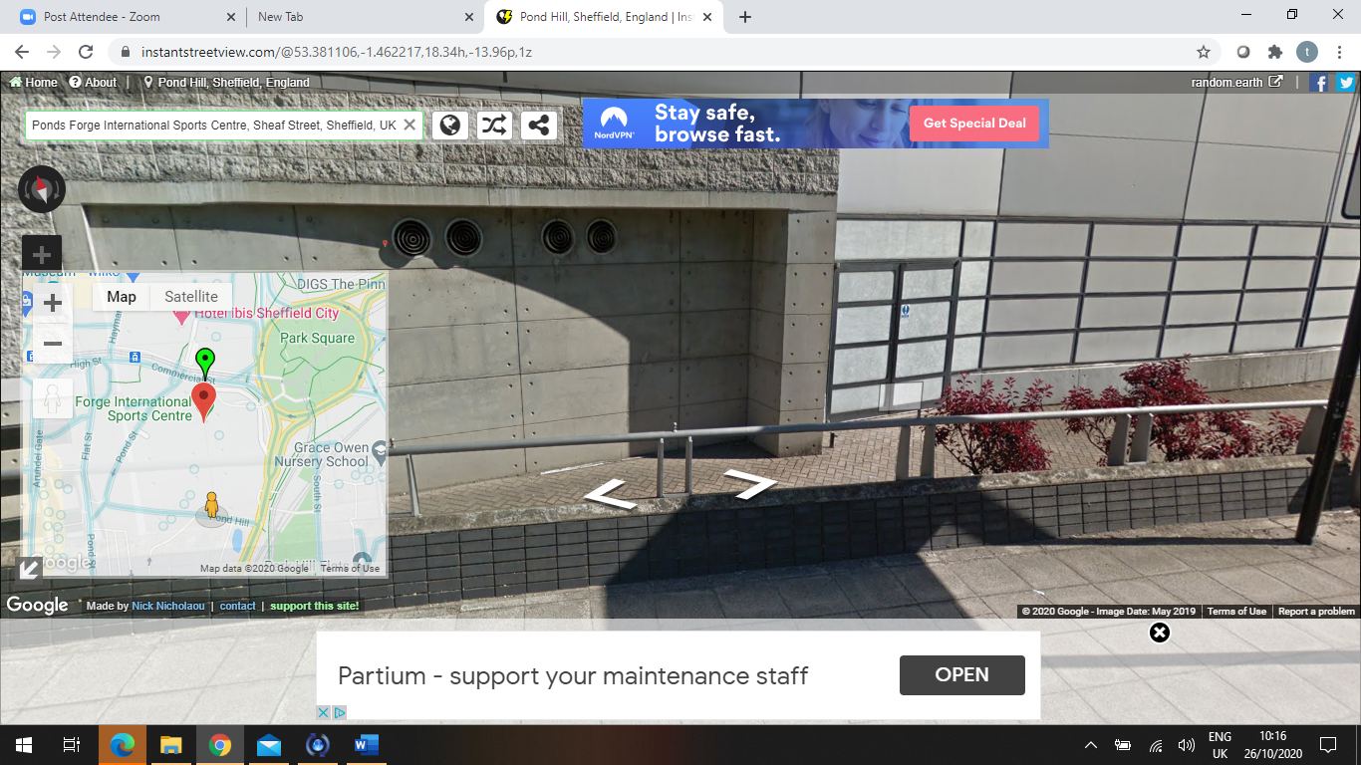
- Trainees – please liaise with your instructor prior to the day as the lesson plan may be discussed either over a zoom call or in the car park in advance of training.

6. Use of Ponds Forge pool facilities
a) Hand sanitisation liquid will be available to the left of the doors used as an entrance & must be used by all attending
b) Face coverings must be worn whenever inside the building unless in the water
c) Dive kit is to be placed close to the walls around the pool (please ensure social distancing is maintained).
d) There are no storage lockers for clothing/personal possessions this should be placed close to the walls surrounding the pool. As cleaning of the poolside is to be undertaken by Ponds Forge between sessions please be aware that the poolside may be wet
e) We are able to retain the 2 storage cages for club kit, this is to be removed from the store room by a minimum of 2 people (due to weight) to the wall around the pool & chocked to prevent rolling in to the pool. The cages must be returned to the storage room as soon as possible after the pool session.
f) DO NOT SPIT INTO MASKS TO PREVENT THEM FROM ‘FOGGING’ as this will generate droplets into the environment. Use a proprietary defogging product, biodegradable baby shampoo or a slice of raw potato (which can be kept in a waterproof container).
g) Swimmers/ snorkellers, 2 lanes will be formed to the side of the pool closest to the competition pool. The lane closest to poolside to be used by swimmers & the lane adjacent by snorkellers. Diving is not to be undertaken under these lanes unless they are not in use (i.e. no one is using the lane rather than no one is above at that time)
h) Snorkellers to use snorkels with an exhaust vent at the bottom i.e. so that breaths disperse in to the water rather than direct in to the air.
i) All regulators, BCD’s and masks belonging to the club & used by a member must be passed to the Equipment Officer in order that they can be transported for cleaning (please assist the Equipment Officer by taking these to their car)
j) The valve of any club cylinder used should be wiped with an antiseptic wipe (these are in the storage cage) prior to placing back in the storage cage. If any cylinder contains less than 80 bar please advise the Equipment Officer in order that a fill can be arranged.
k) After the pool session NO CHANGING FACILITIES will be available, please be discrete when changing pool side.
j) All should avoid using wash/toilet facilities if possible but if used, then wash hands thoroughly, use hand-sanitiser where possible and not touch their mouth or nose. Ladies & gents toilet facilities are available alongside the storage room, maximum of 2 people in each at any one time. These are not to be used for changing.

7. Dive / Snorkelling Equipment:
a) COVID-19 can remain present outside of the human host on materials such as plastics and stainless steel for an unknown period of time, this includes swimwear, wetsuits clothing & towels.
b) Dive/ snorkelling equipment should be cleaned and cared for in line with the manufacturer’s recommendations. The use of inappropriate cleaning agents or procedures may lead to injury to the diver or damage to the equipment. During this period increased risks from COVID-19 additional precautions may be considered to include any personal equipment that is intended for use by another diver in an emergency (AS and BC mouthpieces) can additionally be soaked in a suitable disinfectant solution for 10 minutes. Any equipment soaked in disinfectant solution should be thoroughly rinsed in fresh water before further use and allowed to air dry thoroughly before storage. The owner should avoid touching any mouthpiece that is intended to be used by another diver in an emergency. This applies to club equipment that is usually shared during training.
c) Club kit: if using club equipment this must be handled only by the user & following use will be required to be disinfected (this may require the equipment to be removed from the pool for the purpose of cleaning), cylinders should be cleaned with a disinfectant wipe prior to storage.
d) Cylinders: Compressor operators, people transporting cylinders and those assembling scuba sets should avoid touching or otherwise contaminating the outlet of the cylinder or the first stage of the regulator that connects to it. Cylinders provided for filling should be handled the minimum amount necessary. Compressor operators should lift and move cylinders by a carrying handle if fitted and should avoid touching or otherwise contaminating the outlet of the cylinder or the first stage of the regulator that connects to it. If it is necessary to replace damaged or displaced ‘O’ ring then clean single use disposable gloves should be worn.

8. Dive Briefing / training:
All practical training should be undertaken following 2m social distancing and adhering to all rules and guidance specified elsewhere in this document.
Rescue breaths - Whilst the risk of transmission might be very low, the training and assessment of in-water rescue breaths should not be practiced at this time even with the informed consent of all participants involved.
Briefing of a dive group should continue to be conducted. The briefing should include any additional specific risks relating to precautions to manage and control the risks associated with avoiding the transmission of COVID-19. This includes ensuring appropriate social distancing by those attending the briefing.

9. Kitting up/assistance
Donning heavy scuba equipment benefits from having assistance to avoid injury in trying to fit alone. Where possible making use of benches or similar platforms to reduce the need to lift heavy equipment, may be beneficial. If assistance must be provided it is recommended that:
The equipment is prepared in advance by the user
The assistance is for as brief a time as possible
The assistant/buddy does not touch any part of the equipment that would be breathed from directly by anyone
During assistance both participants wear a face covering mask whilst within 2m of each other as a means of limiting exposure
Do not spit into masks to defog them, as this will generate droplets into the environment. Use a proprietary defogging product, biodegradable baby shampoo or a slice of raw potato (which can be kept in a waterproof container).

10. Buddy Checks:
A buddy check remains an essential safety procedure for diving. Checks can be completed as normal with the buddy pair positioned 2m apart.
The diver should breathe off their own regulator while monitoring their pressure gauge, simply to check function.
During the buddy check the diver who would use an alternative source (octopus regulator) should check the function of same by breathing from it whilst monitoring the pressure gauge.
When demonstrating oral inflation of a BC, contact with mouth or hands on the mouthpiece should also be avoided. Inflate the BC with low pressure inflator, demonstrate venting options, then clearly show the actions required for oral inflation.

11. Entry and Exit procedures:
Where possible during water entry, exit all should maintain a 2m separation if breathing surface air. If divers require to be in closer proximity to a buddy eg. for support then both divers should have masks and regulators in place, as is normal practice, and ensure they only breathe from their own gas sources.

12. Swimming/snorkelling/divers on surface:
Swim England advise that It is acceptable for swimmers in a session to pass each other at less than 2 metres distance as long as that is for a short time and only when swimmers are in motion.
It is imperative that swimmers maintain social distancing when static either in or out of the water.
Divers on the surface must ensure that their mask & regulator are in use unless they are more than 2 meters from any other pool user.

13. Out of gas procedures:
An out of gas (OOG) situation underwater is a life-threatening concern. All divers are trained to deal with such situations both for themselves and to assist a buddy. The Alternative Source (AS) should be dedicated to use by a buddy and not breathed from by the diver themselves. BSAC preferred method of teaching is for an OOG diver to take the dedicated AS (or be presented it by their buddy) and the buddy to retain their own primary regulator.

14: Post Dive debrief:
Discussion of a dive between a buddy pair can be completed as normal whilst maintaining a social distancing separation of 2m. Debriefing of a trainee(s) by the Instructor should continue to be conducted ensuring appropriate social distancing by those attending.

15. In the event of any incident/illness:
Should anyone attending become unwell or develop whilst at the pool the symptoms of Covid-19 they should leave the pool immediately & return to their home / medical facility if appropriate directly. If Covid-19 is confirmed within 14 days of attending the pool the DO (Matt Newbound), Chair (Tessa Fisher), Secretary (Susan Gill) & Membership secretary (Ash Jessop) must be notified without delay in order that all persons present at the pool may be notified.

CPR and Rescue Breaths If you are required to perform cardiopulmonary resuscitation (CPR), you should conduct a risk assessment and adopt appropriate precautions for infection control. In adults, it is recommended that you do not perform rescue breaths or mouth-to-mouth ventilation; perform chest compressions only. Compression-only CPR may be as effective as combined ventilation and compression in the first few minutes after non-asphyxial arrest (cardiac arrest not due to lack of oxygen). If a decision is made to perform mouth-to-mouth ventilation in asphyxial arrest, use a resuscitation face shield where available. Should you have given mouth-to-mouth ventilation there are no additional actions to be taken other than to monitor yourself for symptoms of possible COVID-19 over the following 14 days. Should you develop such symptoms you should follow the advice on what to do on the NHS website. Any member of a dive party trained in the delivery of CPR and Rescue Breaths (RB) should consider their own Risk Assessment and decide their position on whether or not they would provide this first aid should they be called upon to assist another diver requiring CPR and/or RB. Factors to include:
Personal attitude to risk of infection versus saving a life?
Assessment of likelihood to require RB inclusive CPR
Availability of AED (what happens if voice prompts indicate give RB?)
The likely response time of the emergency services or advanced care
Available PPE
Assessment of response times for emergency services

Training • All practical training should be undertaken following 2m social distancing and adhering to all rules and guidance specified elsewhere in this document. • Rescue Breaths: In the event of a serious incident whilst diving/snorkelling the ability to provide initial in-water rescue breaths can be a significant contributor to a successful rescue. The training for this skill remains an essential training requirement for qualifications beyond entry level. Whilst the risk of transmission might be very low, the training and assessment of in-water rescue breaths should not be practiced at this time even with the informed consent of all participants involved. This will impact on the award of qualifications that include such skills training as they cannot be signed off until all required skills are completed (Sports Diver, Dive Leader, Advanced Diver). The use of simulation methods (such as leaving the scuba mask in place and forming a seal over it) can lead to the simulated method being used in a real rescue attempt, with consequent failure of the method. These methods do not offer sufficient protection from virus transmission. Current guidance is to avoid such methods. • CPR training on land must only be conducted with a manikin. Following Resuscitation Council UK advice normal hygiene procedures should be maintained for manikins used for RB and CPR practice. All surfaces subject to direct personal contact (chest, forehead and face) should be thoroughly cleaned using disinfectant/alcohol wipes and allowed to dry naturally between each user. Replace and dispose of manikin lungs and airways after each training session. Clean manikin heads with an appropriate surfactant/disinfectant solution after completion of each training session and allowed to dry naturally. • Casualty Assessment: During the current restrictions it is recommended that a person is NOT used as a simulated casualty and wherever possible a full body manikin is used instead.

Other concerns / information
• Wear face coverings if you can. Wear a face-covering in an enclosed space where full social distancing isn’t possible. Also where you will come into contact with people you do not normally meet. Homemade cloth face-coverings can help reduce the risk of transmission in some circumstances. Face-coverings are not intended to help the wearer, but to protect against inadvertent transmission of the disease to others if you have it asymptomatically. The evidence suggests that wearing a face-covering does not protect you, but it may protect others if you are infected but have not developed symptoms. • PPE Guidance is available on the BSAC website here: https://www.bsac.com/document/ppeguidance • Please consider the environment when obtaining PPE and also planning trips to sites where everyone will have to travel separately. An example washable face mask is available from Amazon (the club is not endorsing this mask, just providing it as an idea for members): https://www.amazon.co.uk/Reusable-Protection-Breathable-PollutionMotorcycle/dp/B086XJB9WY/ref=sr_1_1?dchild=1&keywords=neoprene+face+mask&qid=1 591887550&sr=8-1

